The Pueblo to People Committee
and
The 46 Rosary Devotion to Our Lady of Guadalupe
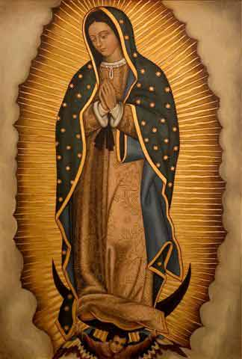

This year, the Pueblo to People committee invites you to start the celebration of Our Lady of Guadalupe by joining the Mexican tradition in praying a daily rosary for 46 days straight, from October 28 until her December 12, feast day. The number 46 corresponds to the number of stars that surround the image of our lady of Guadalupe as seen on St. Juan Diego’s tilma. This devotion of praying the 46 rosaries goes back to at least a century ago.
Please Join us on Thursday October 28, in the church from 7:00 to 7:30 pm to start the devotion of praying the first rosary together in person and continue praying the rest of the rosaries from the comfort of your homes. Pray one rosary for each star that can be appreciated on the mantle of Our Lady of Guadalupe.
We are also placing prayer cards in the gathering hall by our bulletin, where you can see the image of Our Lady of Guadalupe with the 46 stars in the mantle. We will be adding one star per day until we complete the 46 stars.
As you pray for your intentions, please remember our Sister Parish community of San Antonio de Padua – Parroquia Granjas, in Yucatan, Mexico.

Names of the stars for each day of the 46 rosaries in Honor of Our Lady of Guadalupe

– October 28 – Star of Wonder – October 29 – Star of Joy
– October 30 – Star of Beauty – October 31 – Ever Virgin Star
– November 1 – Evangelizer Star – November 2 – Compassionate Star
– November 3 – Our Mother Star – November 4 – Our Lady Star
– November 5 – Messenger Star – November 6 – Patient Star
– November 7 – Humble Star – November 8 – Impeller /Promoter Star
– November 9 – Committed Star – November 10 – Faithful Star
– November 11 – Mother of Christ Star – November 12 – Powerful Star
– November 13 – Sorrowful Star – November 14 – Grateful Star
– November 15 – Queen of Hope Star – November 16 – Star of Solidarity
– November 17 – Welcoming Star – November 18 - Star Educator
– November 19 – Star Benevolent – November 20 – Consoling Star
– November 21 – Queen of Unity Star – November 22 – Queen of Trust Star
– November 23 – Obedient Star – November 24 – Resilient Star
– November 25 – Respectful Star - November 26 – Beloved Star
- November 27 – Dialogue Star – November 28 – Witness Star
– November 29 – Queen of the Covenant Star – November 30 – Reconciling Star
– December 1 – Servant Star – December 2 – Guadalupe Star
– December 3 – Missionary Star – December 4 – Admirable Star
– December 5 – Light Star – December 6 – Comforting Star
– December 7 – Amiable Star – December 8 – Immaculate Star
– December 9 – Flower of flowers Star - December 10 – Mother of Heaven Star
– December 11 – Star of Courage and Motivation – December 12 – Perfect Star

